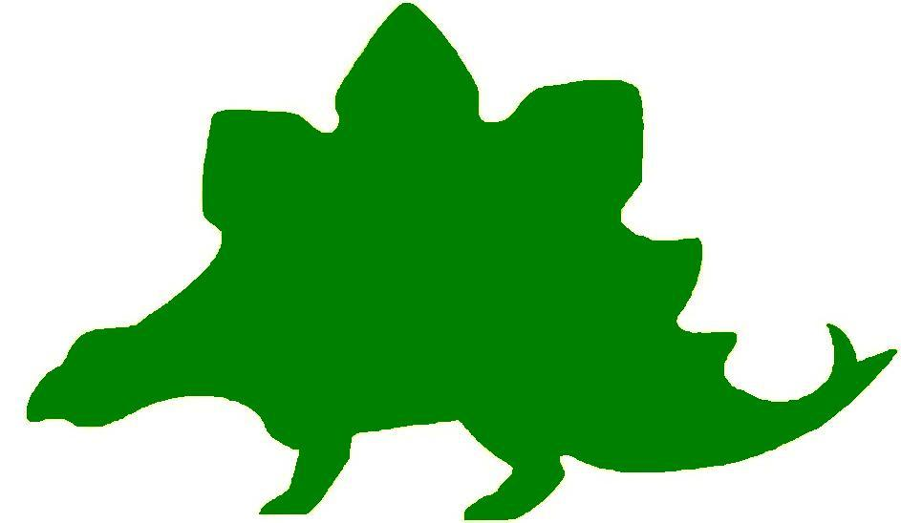
theHoustonMuseumofnaturalscience

2nd Grade Knowledge Hunt
Dear Educator,
Thank you for downloading the free, online curriculum available at HMNS! We’re thrilled to see that you are including the world-renowned Houston Museum of Natural Science in your educational toolkit.
Here at HMNS our mission has always been to provide exemplary educational opportunities for the community. Providing educators like you with free, fully editable curriculum is just one of many ways we are fulfilling that mission.
Thank you again, and we hope you enjoy your field trip to HMNS!
Best,
The HMNS Staff

How to use this guide:
- Feel free to edit the questions as needed to suit your student group.
- The Knowledge Hunt is structured to begin at the top of the Museum (floor three) and work its way down to the lower level.
- Visitor services and security staff are posted around the Museum and will be happy to assist you in finding any of the locations mentioned.
- Please ensure that one chaperone is with every group of ten students at all times as they complete these activities.
- Don’t forget to download our extension activities for use in the classroom when you return from your trip!

Please direct any and all questions to curriculum@hmns.org

2nd Grade TEKS Objectives

Each of the following TEKS Objectives are met as students explore the various exhibit halls and complete the Knowledge Hunt:
Science: 2.1 (A, C), 2.2 (A, B, C, E, F), 2.3 (A, B, C), 2.5 (A, D), 2.6 (D),
2.7 (A), 2.9 (A, B, C), 2.10 (A, B)
Social Studies: 2.1(B), 2.2 (A, B, C), 2.3 (A,B), 2.4 (C), 2.5 (A,B), 2.6 (A, C), 2.7 (A,B), 2.8(A,C,D), 2.10 (A,B,C), 2.11(A, C), 2.15 (A), 2.16 (A), 2.17 (A, B,D,E), 2.18 (A,B), 2.19 (A,D)

ELA: 2.2 (A), 2.3 (C,E), 2.4 (A,B,C), 2.7 (B,C), 2.8 (A,B,C,D),
2.9 (A,C,E,F,H,I), 2.10 (B,C,D), 2.11 (C),
2.12 (A,D,E,F,G,H), 2.13 (A,B), 2.14 (A,B,C,D),
2.15 (A,B,C,D), 2.16 (A), 2.17 (A,B,C,D), 2.18 (A,B,C,D,E,F), 2.20 (B,C,D)
Math: 2.2 (B), 2.7 (A,B), 2.9 (C), 2.11 (A,B), 2.12 (D)

McGovern Hall of the Americas

Third Floor

Vocabulary:
natural resources, parka, kiva, kachina, ceremonial, tipi, ventilation, panfleche, cacao

Ritual and Religion
Show the students the display of masks. Explain that masks have been used by dancers for 2,000 years so the audience watching will think of the dancer as something other than a human. Masks like these are still being used in Mexico to link the past with the present. Ask students to guess what some of the masks represent.

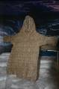

The Arctic
Ask students to look at the items in the display. Read the information in the text panels to explain to the students the significance of the objects. Ask the students what kind of climate these items would be found in. Ask them if we would find these items in our own climate and to explain their answer.

The Northwest Coast
Explain to the students that natural resources are materials used by people that occur naturally in the environment. Ask the students if they can find some examples of how the people of the Arctic and the Northwest Coast use natural resources in their daily life. Help them find the parka made of seal gut, the toys made from ivory, the totem, and the cooking materials.

The Southwest

Kiva
Explain to the students that the kiva was made of two natural resources, stone and mud. These were good building materials because these building materials kept the kiva cool in the hot summer and warm in the cold winter. Ask the students why they think the people who built it used these materials instead of something else.

Hopi Kachinas
Show the students the display of kachinas. Tell them that the kachinas are spirit beings representative of everything in the Hopi universe. Hopi people believe they come down from their home in the mountains in December and live in the villages for six months. The people of the village ask for rain, good crops, and other blessings by dressing in costumes and participating in ceremonial dances to celebrate the importance of the kachinas. The kachina dolls are symbolic of these spirit beings.

Ask the students to pick their favorite kachina. Help them read its name and ask them why that kachina might help the Hopi people.

The Plains

Tipi
The Plains Indian tipi was portable, sturdy, and comfortable. As the students look at it, point out some of the features. There is a smoke hole at the top to provide ventilation for the fire. The door faced east to welcome the morning sun. Beds were made of buffalo hides. The decorated panfleche bags were made of rawhide. These storage containers were very important because they carried food, clothing, and personal items as the Plains Indians moved to follow the herds of buffalo.

Aztec
Before entering the Aztec city, stop at the large figure of the jaguar. Tell the students that the jaguar was placed near the cacao fields to protect it. Ask the students if they know what is produced from the cacao bean. After telling them that chocolate is made from the bean, explain that the Aztecs discovered chocolate and traded it for other goods. It was an important element of their economy. Ask them why they think the jaguar was chosen to protect the fields.

Explain to the students that a lot of information can be gathered by looking at the artifacts of a civilization. Walk the students through the Aztec city. Point out the trumpet shells, the figures playing musical instruments, the figures holding a ball and a cocoa cup, the 2,000 year old sculpture of the ball game, and the symbols of nature. Ask the students to describe what they know about the Aztec civilization from looking at the objects in the display.

As the students leave the Aztec city, point out the Laughing Figure in the case. After seeing so many relics from the Aztec culture and learning a little about their life, ask the students why this figure may have been laughing.

Hall of Ancient Egypt

Third Floor

Vocabulary:
agricultural, community, fertile, compass, Dynasty, civilization, archeologist, drought, domesticated, valley, hunter-gatherer, Pharaoh, capitol

Egypt Gift of the Nile
Read the text panel to the students. Ask them the following questions:
When did the first African civilization begin?

What did the annual Nile flood do to the soil?

Timeline of Egyptian History
Ask for three volunteers from the group. Place each volunteer at a different point of the timeline listed below.

Early Dynastic Period

Bust of Queen Nefertiti

North America Hopewell Culture

Tell the group to pretend that the person standing in front of the “Bust of Queen Nefertiti” entry is present day. Now ask them to pick which volunteer is standing in front of the entry that happened in the past and which is standing in front of the entry that will happen in the “future”. Be sure that the students understand how a timeline works. Try this activity a couple of times until they grasp the concept of past, present, future and that a timeline is a list of events in the order that they happened.

Egypt’s Ancient Roots
Read the text panel to the students to answer the following questions.

How do archeologists know there were humans near the Nile River during the Early Stone Age?

What forced human hunter-gatherers into the Nile valley?

According to the text panel, once the extreme drought ended, which animal became domesticated?
- Goat b. Cow
- Horse d. Cat

The Predynastic Period (6000 – 3100 BC)
Map: Show the group the map on the text panel. Point out that Northern Egypt is called Lower Egypt and Southern Egypt is called Upper Egypt. Also indicate the location of the Nile River that flows through Egypt. Now ask the students to guess why North = Lower Egypt and South = Upper Egypt. After you have given them time to speculate explain that the Nile River is the key to this mystery. The River flows from south to north unlike rivers here in the United States that flow from north to south.

Pharaoh – Lord of the Two Lands
Read the text panel to the students to answer the following questions.

Who was in charge of Egypt?

What was the King’s job?
a. make laws b. collect taxes
c. defend Egypt d. all of the above

What does “Pharaoh” mean?
a. great house b. great ruler
c. the White House d. none of the above

Temples
Read the text panel to answer the following questions.
What were temples made of?

Why were they made of stone?

Can you think of a building in Texas that is made of stone? (*Hint: It is in Austin)

Roman and Byzantine Egypt (30 BC – 641 AD)
Map – Look at the world map on the text panel. Locate Egypt. Which direction is Rome located from Egypt?
a. Northeast b. Northwest
c. Southeast d. Southwest

Strake Hall of Malacology

Second Floor

Vocabulary:
malacology, civilizations

Family Cypraeidae (Cowries)
Help the students find this display of shells. Point out #1 Cypraea moneta (money cowrie). Tell the students that these small shells were once used as money by early civilizations. Ask the students why they think this would be a good form of money.

Point out #16, Cypraea mus (mouse cowrie). Ask the students if they think this cowrie looks like a mouse. Point out the little body and small ears at the top. Point out other cowrie shells that have animal names: #27 Cypraea testudinaria (turtle cowrie), #29 Cypraea cervus (Atlantic deer cowrie), #30 Cypraea mauritiana (humpback cowrie), and #31 Cypraea tigris (tiger cowrie). For each one, ask the students if they can tell how that shell got its name. Is it because of its color, size, shape, etc.?

Ask the students to look at #23 Cypraea mappa (map cowrie). Ask the students of they see the map on the back of the shell.

Family Xenophoridae (carrier shells)
Lead the students to the case containing the carrier shells. Ask the students to look closely at the shells and tell you what is unusual about them. Ask them why they think the large shell is “carrying” smaller shells on it.

Family Pleurotomariidae
Locate the Candelabrum Whelk that was found in Port Isabel, Texas. Ask the students if they have ever found a shell that large while walking on a beach. Have the students walk around the case and look at the little flap at the opening of the shell. Ask the students how they think that flap is used.

World’s Largest Snail Shell
Show the students the Australian Trumpet that measures 30 inches in length. Ask the students to name some other things they know are that size.

Cullen Hall of Gems and Minerals

Second Floor

Vocabulary:
faces, mineral, angles, edges, vertices

Case # 16
Ask the students to look at the Galena in the case from all sides. How many different faces do the students see on the mineral?

Case #25
Ask students to look at the Cerussite from all different angles. How many different faces do the students see on the mineral?

How is this mineral different from the one they saw in case 16?

Case #26
Have the students find the Cerussite in the case. Ask students if they can think of a math question about the mineral that has to do with fractions.

Case #42
Ask the students to find the Pyrite in the case. Let them look at it from all sides. How many edges does the mineral have?

Ask students to guess the length of the edges of the Pyrite. Write down their guesses.

Case #76
Let the students find the Hydxorylherderite in the case. Can they find triangular shapes on the mineral? Ask students how many vertices they see in the mineral.

Farish Hall of Texas Wildlife

Second Floor

Vocabulary:
environment, characteristics, adaptation, sanctuary, predators, prey, food chain, food web

Coastal Wetland & Marsh
As you bring students over to this ecosystem, remind them that animals adapt to their environment differently. Even similar animals sometimes adapt in very different ways – such is the case with birds.
Point out the various waterfowl that are swimming in the pond. Ask students to describe the beaks and feet of these birds.
Draw student attention to the Osprey and Bald Eagles roosting in the trees. How are their beaks and feet different? Ask students to explain why these birds look so different.
High Plains
The High Plains region of Texas is located in the northwestern area of the state, whereas the Coastal Wetlands are in the southeast. Ask students to compare what they see in these two sections. Use the following questions to guide students:
How do the High Plains look compared to the Coastal Wetlands?

Which region do you think receives more precipitation?

In which region would it be easier for animals to hide?

What adaptations to animals in the High Plains have to escape predators?

What animal do you think is the primary predator in this region?

Guadalupe Mountains
Tell students to examine the different animals that live in this region. Tell them to describe the environment. Use the following questions to guide students:
Which animals within the environment are carnivorous?

Which animals are prey animals?

How do prey animals protect themselves?

Point out the Desert Bighorn Sheep, high on the mountain top. Explain to students that these animals are expert climbers. Ask them to guess what adaptations they have to help them climb.

Piney Woods
Using the identification text panel, encourage students to use the blank space below to create a food chain, starting with the plants. Try to include each of the following animals: Flying Squirrel, Barred Owl, Timber Rattlesnake, Black Bear.
Note: Though there are none visible in the exhibition, encourage students to add berries and insects to their web if necessary.
Piney Woods Food Chain

Rio Grande Dry Forest
Tell students that one important adaptation animals have is their coloring. It allows them to hide in plain sight. Bring students over to the main text panel for this region and challenge them to find as many of the animals listed as possible. Ask them which ones are the best camouflaged (hardest to find).

Coastal Oak Motte
Ask students which animals they see that are different from the other regions they’ve seen so far. Ask them what they think the animals living in this environment need to survive.
Point out the wild turkey. As students if they think the turkey would survive if it was put in one of the other regions (for example, the Guadalupe Mountains). Make sure students justify their opinion.

Coastal Prairie
For each of the following animals, ask students to explain at least three adaptations it has to help it survive in this region.
Animal | Adaptation #1 | Adaptation #2 | Adaptation #3
American Bison
Striped Skunk
Barn Owl

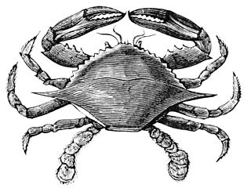

Hamman Hall of Texas Coastal Ecology

Second Floor

Vocabulary:
ecosystem, habitat, ecology, endangered, food chain, tidal, reef, bay. imprint

As you enter the Hamman Hall of Texas Coastal Ecology, adjacent to the Farish Hall of Texas Wildlife, explain that the Texas Coast is another important ecosystem in our state, important to many types of plants and animals (humans too!). Explain that ecology is the study of how organisms interact with their environment, and that a change in a habitat affecting one type of animal might affect other animals as well.

Upper Coast

Map of Coastal Region
Locate Harris County on the map of the Texas coast. Explain that this is where Houston is, where you and the students are standing at this very moment. How close are we to the ocean? Explain that Houston is part of Texas’ coastal plains. Have any of the students ever gone to the beach?

Oyster Reefs
Show students the display of an oyster reef (yes, these are real oyster shells!). Ask them what they see in the display, including any images in the background. As students describe the oyster reef in detail, have them classify each object as “natural” or “man-made”. Oysters are living creatures that can only survive in certain conditions. Discuss with students how some man-made objects, like trash or motor boats, might affect oysters.

Middle Coast

Brown Pelican
The Brown pelican was listed as an endangered species. Show students the maps of Brown pelican populations (larger circles represent larger numbers of pelicans in the area) over time. Explain that when there are very few of a type of plant/animal left, it is listed as “endangered,” or in danger of becoming extinct. Based on the maps, how has the number of Brown pelicans changed over time? Point out that pelicans are growing as a result of humans trying to preserve this amazing bird.

Video
Watch the video at the end of the Middle Coast section with your students. Have students watch the short clip from beginning to end and challenge them to estimate the number of empty milk jugs they see. How many are there? Too many to count! The narrator talks about a “never ending cycle” of picking up trash. Brainstorm with students about a way to stop this cycle and stop trash from ending up in the ocean where it harms wildlife.

Lower Coast

Kemp’s Ridley Sea Turtle
As you round the corner of the Lower Coast section, you will see a large turtle. What is she doing? How many eggs does she have? Explain that sea turtles like this will bury their eggs in the sand to protect them.
When the baby sea turtles hatch, they will imprint, or “mark” the beach they are on as their home. In what ways do we “belong” to a certain area and call it home?
Can students find the baby sea turtles in this exhibit? In what ways do they resemble their mother?

Frensley Hall of African Wildlife

Second Floor

Vocabulary:
desert, ecosystem, niche, environment, organism, pollinate, rainforest, species, savannah

Africa Map
Ask the students to predict where they think the deserts exist in Africa. Ask them to explain their answer.

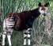

Congo Exploration
Ask the students if they can find an animal in this environment that looks like it is made up of three animals. Point out the okapi to the students if they can not find it. Ask the students to tell what different animals they think the okapi resembles.
Head:
Body:
Legs:
Tail:

Living Together in Harmony
Ask the students to look at all of the different animals that live together in this one ecosystem. Tell the students that a niche is the role an organism plays in a specific environment. Niche includes such things as where the animal lives, where and how it gathers food, its role in the food chain, what it gives to the environment, its habits, periods of activity, etc. For example, the birds in this environment help the plants by keeping the insect population down, by pollinating, and by dropping seeds to replant the forest. Ask the students why they think all of these animals can live together in harmony.

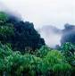

Rainforest
The rainforest is important because many species live there that can not exist in any other environment. There are plants in the rainforest that provide medicines and food that can not be found anywhere else. Tell the students that the rainforest is being threatened because they are being cut down or burned to provide more land for building. Ask the students if they believe saving the rainforest is important and to give a reason to support their answer.

Savannah
Explain to students that wildlife benefits from color to provide protection in their environment. Point out the lion. Have the students notice that the lion’s color is the same as the grass in the savannah. Ask the students to suggest how the lion’s coloration helps it hunt prey.

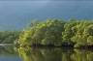

Okavango
Ask the students what animals they see in this environment that they have not seen in any of the other African exhibits. Can they explain what this area has that allows for a more diverse animal population?

The Sahara
Read the text panel to the students. Ask them if they know what migration means. Once you have established that songbirds must fly thousands of miles from Europe across the deserts of the Sahara to reach their winter homes, see if the students can tell you why this is such a difficult task.

The Morian Hall of Paleontology

First Floor

Vocabulary:
adaptations, aerodynamic, specimen, solar panel, stone tools, carnivores, herbivores

Stromatolites
Look at the four stromatolites on the right side of the display as you walk into the Hall of Paleontology. Ask the students to describe the color of these specimens. Explain that almost all rocks have iron minerals in them. Ask the students to tell you what happens to iron when it is exposed to oxygen for a long period of time. They should say that it will rust. Ask them to describe the color rust. Now point out the fifth specimen on display called “banded iron”. What color is this specimen? See if the students can figure out what that means about the atmosphere around this specimen. Explain that this banded iron became very important to scientists because they know that during the time of this piece there was plenty of oxygen in the air. Plenty of oxygen means that more complex life forms could now live on Earth.

Trilobite Timeline
Look at the trilobite timeline and ask the students to guess why the last living trilobite was so small. They might mention that the smaller you are the more difficult it would be for a predator to find you. Point out the eyes of the trilobite over time. Ask the students to guess why the eyes have adapted from looking almost down to looking almost up (or to the side). Explain that trilobites were not concerned with predators at first, but eventually had to adapt to be on the “look out” for anything looking to eat them.

Dimetrodon
Look at the model of the Dimetrodon on display. Ask the students to suggest reasons as to why these creatures have such a tall back. Explain that some scientists believed they used their sailed back as a sort of solar panel to warm their bodies. More recent discoveries suggest they used their sailed back to attract a mate. This would be very important to help carry on the species. Another use for the large back might be to warn off any enemies or predators in the area. It would make the Dimetrodon look large and scary. Ask the students to tell you which scientific theory they like best.

“The Triassic Predator from Post, Texas”
Show the mural titled “The Triassic Predator from Post, Texas” and point out the Pterosaur flying across the sky. Ask the students what adaptations helped the Pterosaur fly. Explain that the wings might be the most obvious but there is more to the story. Let the students think about this and give answers. They should note the tail which helped the Pterosaur change directions (much like a rudder on a boat). They might mention that the head is narrow and aerodynamic. Another trait the Pterosaur had to help them fly was their light or hollow bones.

Horseshoe Crab
Look at the sand imprints the horseshoe crab left behind. Notice that as you look at the imprints close to the horseshoe crab they are closer together until the crab finally stops. Ask the students if they can tell the story of this horseshoe crab. Once a few of them have guessed explain that the horseshoe crab moved from water that had a lot of oxygen to less and less oxygen. Once the oxygen decreased the horseshoe crab was not able to survive.

Deinonychus The Kickboxing Dinosaur
Ask the students to look at the raptor on display. Do they think he was fast or slow? Point out the large claw on his back feet. Ask the kids to guess why the claw would be there instead of on the front hands. Explain that these raptors had very strong back legs and they would kick up their back legs (essentially kickboxing) when attacking prey. This claw packed a big punch!

The Late Cretaceous
Look at the mural behind the raptor. Point out the Triceratops and the Tyrannosaurus rex. Ask the students to list the food chain they see in this scene. Keep in mind the Triceratops is an herbivore and the Tyrannosaurus rex is a carnivore. They should mention that the trees and plants provide food for the Triceratops, and the T-rex will eventually eat the Triceratops.

Lane Triceratops Skin in 3D
Take a moment to look at the largest portion of Lane’s mummified skin displayed on the wall. Point out the nickel size indentions. Ask the students to think like scientists and create a theory of what those indentions were for. After they have come up with some ideas, tell them that after careful study of Lane’s skin scientists discovered that these areas once held some sort of quill or course bristle. In the mural you just saw you will have noticed the bristles coming out of the Triceratops’ back. Scientists believe that this is what a real Triceratops would have looked like.

Giant Bull Mammut Americanum
Mastodons and mammoths were good walkers and swimmers and were able to spread across the globe. Ask the students why they think these creatures would be interested in moving and spreading out from their original location in modern day Africa. Students should consider climate changes and the need for these large animals to eat large amounts of food. The mammoth and mastodon were big, furry, and herbivores. They needed cool temperatures and lots of plants and tree bark to survive. As the environment changed around them they had to move from place to place. Once cavemen started hunting these large animals they contributed to their extinction.

Stone Tools
Ask the students to look at the stone tools from left to right. Ask them how they have changed over time. They should notice that these tools look sharper and more like real weapons as they look from left to right. Explain that as man became smarter, he created more advanced looking stone tools to assist him in the hunt.

Wiess Energy Hall

First Floor

Vocabulary:
microscope, oxygen, renewable, alternative, solar, tidal, porous, permeability, refinery

Formation
Watch the video showing how energy began.

Sea Creatures
Ask the students what these are. Explain that they are plants and animals that live in the sea, but cannot be seen without a microscope. They live and die in the ocean. Since there is no oxygen in the ocean to decay them, the creatures form a rock layer called shale. It is in shale that oil is found.

Energy Exploration Theater
Watch the musical journey to discover how we use oil products, electricity, and natural gas to improve our lives. It also touches on renewable energy sources such as solar power, wind energy, and tidal energy. When students emerge from the theater ask them if they are producers or consumers of gasoline, electricity, and natural gas.

Plate Tectonics
Slowly move the cursor so students can see how continents were once connected in a huge mass called Pangaea. Show them how they separated over millions of years to create the Earth we know today. Help them see where Texas was 200 million years ago and where it is situated today. Show how the United States once had a huge ocean in the middle of it.

At 73 million years ago, show how Texas was covered with water. Ask them how they think this relates to all of the oil found in Texas.

Porosity and Permeability
Press the button to show students how a reservoir rock traps the oil. The larger the space, the more porous the rock and the more oil can be taken out. Both sides start with the same amount of oil in them, but it is harder to recover the oil from the smaller “rocks”. Ask the students to explain why they think this happens.

Process and Products
Direct the students to the large, lighted display of a refinery model. It shows how crude oil, oil straight from the ground, is transformed into useful substances. Molecules are sorted and shaped. The main goal is to make gasoline like we use in our cars, but it also makes jet fuel, heating oil, wax, asphalt, etc.

Energy Excursion Theater
After watching the film, ask the students to name four forms of alternative energy that were explained in the film.
1.
2.
3.
4.

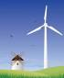

Alternative Energy
Allow the students time to look at all of the alternative forms of energy presented in the display cases. Electricity use is at its highest in the later afternoon in the summer. Ask the students to suggest a reason for this. Ask them when they think electricity use would be at its lowest.

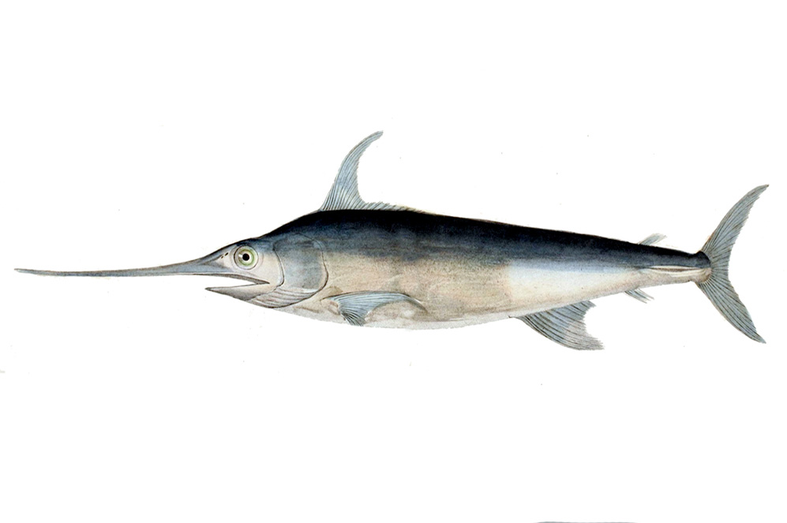
Alfred C. Glassell Jr. Hall

First Floor, Main Entrance

Vocabulary:
environment, characteristics, adaptation, predators, prey, food chain, food web, marlin, biome, marine, deep ocean, dolphin, ecosystem, niche, organism

As you bring students into the Glassell Hall, begin by looking at the big marlin mounted on the wall. Ask students what characteristics the giant fish has. For each characteristic, see if students can identify why it is helpful to the animal’s survival. For example: Gills, fins, tail, nose, frill.

Watch the video to the right of the Marlin caught by Glassell. How heavy was it?

Guide students to look at the ceiling, where numerous fish and dolphin species are represented. Ask students to find the dolphins. Then ask them to find the sharks.

How can they tell the difference between the two? What characteristics do the two species share? What characteristics are unique to each?
Tell students that there are ten different species represented in the hall. Ask them to identify their favorite and draw it in the space below. They will use this drawing for an activity back in the classroom.

Bring students to the video monitor near the Museum’s main entrance. Click on the ‘Marine Life’ option and watch the Ocean Oases video.
How many canyons exist along the eastern coast of the US?

Why are these canyons considered oases?

List at least five different animals that live in these canyons.


The Welch Chemistry Hall

Lower Level

Vocabulary:
matter, filtered, work, lever, pulley, particle, mass, density

Relative Mass
Bring students over to the self-assembly station, and have them observe the tube of oil and water. Allow students to work together to come up with possible reasons why the oil and water are separate. Tell them you are going to flip the tube upside down. Have students predict what will happen. After you flip the tube, allow students to revise their original predictions. Explain that oil and water have different mass and density, so they do not mix.

Corliss Steam Engine
Bring students over to the Corliss engine. Have them observe the spinning wheel and ask them to make predictions about its purpose. Have students observe the various parts of the machine and how they fit together, predicting what the purpose of each part is. Have students discuss what else they could build with similar materials.

Heavy Metal
Bring students over to the heavy metal station and have them examine each of the metal blocks. Give them an opportunity to describe the blocks and how they are similar and different. Explain to students that each handle is connected to a different type of metal. Have students take turns lifting the different metals. Then, in groups, students will explain the differences between each type of metal. Which is the heaviest? Which is the lightest?

Air Particles
Ask students to observe the lights on the ceiling, explaining to them that they represent the particles in the air we breathe. Ask students to use their math terms to determine the following:
- Are the number of purple lights greater than or less than the number of green lights?
- Are the number of pink lights greater than or less than the number of purple lights?
- How many green and pink lights are there total?

Solar System

Outside Main Entrance

Vocabulary:
planets, orbits, solar system

Upon leaving the Museum, allow the students time to look at the solar system on the steps and sidewalk in front. Show the students how large the Sun is in relation to the planets. Show the students where Earth is positioned in relation to the Sun. Ask the students which planets are closer to the Sun and which are further away. Allow the students to step on and name the planets in order from the Sun.

