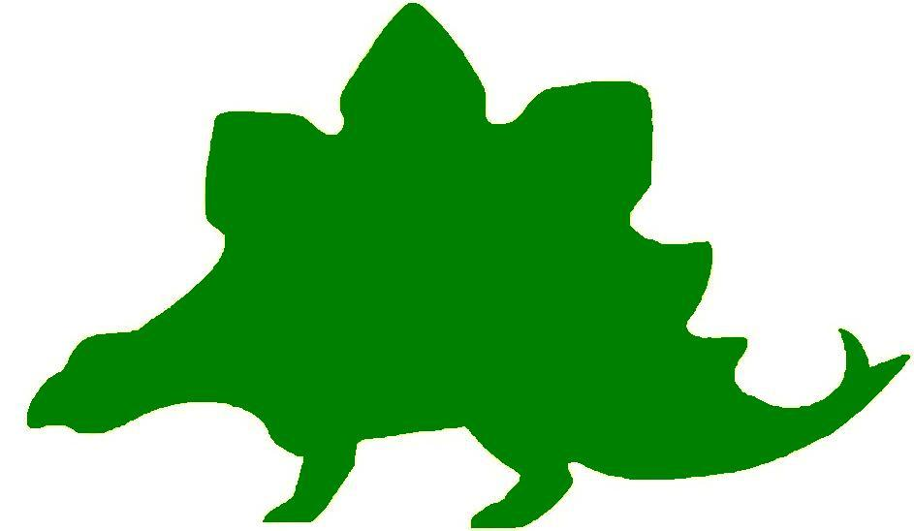
theHoustonMuseumofnaturalscience

6th Grade Knowledge Hunt
Dear Educator,
Thank you for downloading the free, online curriculum available at HMNS! We’re thrilled to see that you are including the world-renowned Houston Museum of Natural Science in your educational toolkit.
Here at HMNS our mission has always been to provide exemplary educational opportunities for the community. Providing educators like you with free, fully editable curriculum is just one of many ways we are fulfilling that mission.
Thank you again, and we hope you enjoy your field trip to HMNS!
Best,
The HMNS Staff

How to use this guide:
- Feel free to edit the questions as needed to suit your student group.
- The Knowledge Hunt is structured to begin at the top of the Museum (floor three) and work its way down to the lower level.
- Visitor services and security staff are posted around the Museum and will be happy to assist you in finding any of the locations mentioned.
- Please ensure that one chaperone is with every group of ten students at all times as they complete these activities.
- Don’t forget to download our extension activities for use in the classroom when you return from your trip!

Please direct any and all questions to curriculum@hmns.org

6th Grade TEKS Objectives

Each of the following TEKS Objectives are met as students explore the various exhibit halls and complete the Knowledge Hunt:

Science: 6.1 (A, B), 6.2 (A, B, C, D, E), 6.3 (A, B, C, D), 6.4 (A), 6.5 (A, B, C, D), 6.6 (A), 6.7 (A, B), 6.9 (C), 6.10 (C, D), 6.11 (A), 6.12 (A, B, C, D, E, F)
Social Studies: 6.1 (B), 6.2 (A, B), 6.3(A, B),6.4 (A, B, C, D), 6.5(A, B), 6.6 (A, B, C,), 6.7 (A, B), 6.8 (A, C), 6.12 (A, B, C), 6.15 (A, B), 6.16(A), 6.17 (A, C, D, E), 6.18 (A, B), 6.20 (C), 6.21 (A, B, F), 6.22 (A, B, C, D, E), 6.23 (A, B)

ELA: 6.1, 6.2 (B, E), 6.9, 6.12 (A, B), 6.13 (A, B, C, D), 6.14 (A, B, C, D, E), 6.15 (A (i-iii)), 6.16, 6.17 (A (i-iv), B, D), 6.18, 6.19 (A (i-viii), B, C), 6.20 (A (i-iii), B (i-iii), C), 6.21 (A, B, C), 6.22 (A, B), 6.23 (A, B, C, D, E), 6.24 (A, B), 6.25 (A, B, C, D), 6.26 (A, B, C), 6.27, 6.28
Math: 6.1 (B), 6.2 (A, B, C, D), 6.3 (B), 6.6 (A, C), 6.8 (A, B), 6.11 (A, B, C, D)

McGovern Hall of the Americas

Third Floor

Vocabulary:
archaeologist, archaeology, artifact, civilization, culture, diversity, flint, lithics, material culture , migrate, non-material culture, totem pole, westward expansion

Prehistoric Stone Tool Technology
What is thought to have been the oldest human industry?

Define lithics

Give two ways lithics can help archaeologists
1.

2.

How to Make a Stone Tool
List four common methods for making stone tools.
1.
2.
3.
4.



A Special Texas Stone
Where is the source of alibates flint located?

How do scientists know that there may have been an extensive trading system as far back as 10,000 BC?

What is Archaeology?
Define archaeology

Why does an archaeologist keep very detailed records and measurements of a site?

How old is that Artifact?
List and define two ways of dating objects?
1.
2.

Prehistoric Cooking
Complete the flow chart below to explain how cooking may have been done in prehistoric times

How do we know this method of cooking was used throughout central Texas?



Clothing and Culture
What factors contribute to a culture’s choice of clothing?

Why does traditional clothing continue to be worn?

Man’s Clothing
Why do the Aymara wear wool garments?

Woman’s Mola Blouse
What are “molas”?

How have the Kuna turned one of their traditions, molas, into an economic windfall?

Woman’s Outfit, Southern Plains Style
What does this contemporary Kiowa outfit suggest about the Plains Indian culture?

What are the traditional dances and social gatherings call?



Cultural Diversity
How did cultural diversity evolve?

What is Culture?
Define and give examples of material culture.

Define and give examples of non-material culture.

Material Culture
Look at the items in the case to the left of the text panel. List as many natural materials as you can see that were used to create these items.

Weaving
Which group is called “Basketmakers”? Explain why.

Tribal Map
As you walk through the Hall of the Americas, use the map below to label the location of the tribes that you are learning about. (You may use the touch screens in each area to help you. Click on “Region”.)

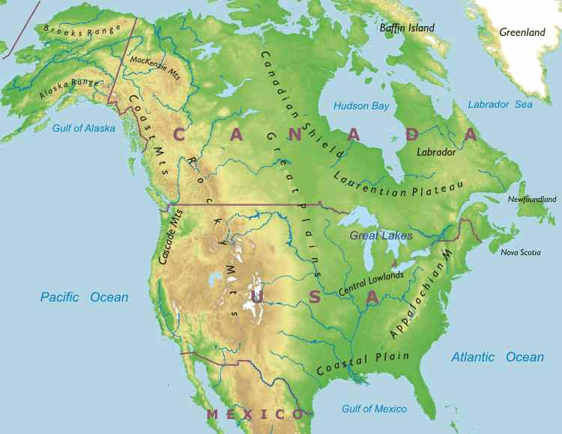

The Arctic
What did the Arctic people hunt until the early twentieth century?

Why do you think the Arctic people’s dependence on hunting has lessened?

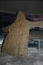

Child’s Seal Gut Parka
Describe how a seal gut parka keeps the person wearing it dry.

Kayak with Paddle
After looking at the Kayak in the display, do you think someone could have used this boat to travel long distances? Why or why not?

Do you think this was the best way to hunt? Explain your answer.

Hunting
Why do you think Arctic people perform rituals to honor intended prey?

The Northwest Coast
What is a potlatch?

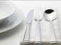

Feasting Traditions
Look at the items in the display case. Why do you think they were so lavishly decorated? Who was being served with these dishes?

Potlach Gifts
List the different gifts given during the three time periods below.

Before European Americans 1850s Today
1. 1. 1.
2. 2. 2.
3. 3.
4. 4.
5. 5.
6. 6.

Look at the lists you’ve created above, why do you think the gifts have changed over time?

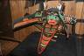

Transformation Mask
How does a transformation mask work?

What does the transformation mask on display represent?

House Post/Totem Pole
List four interesting facts you learned about the House Post/Totem Pole. How many animals can you see while looking at the object on display?
1.
2.
3.
4.
Number of Animals:

The Southwest

What are adobe houses and pottery vessels made of?

“The story of my people and the story of this place are one single story. No man can think of us without thinking of this place. We are always joined together.”
- A man from the Aos Pueblo
Explain what you think the quote above means.

Kiva – Pueblo Architecture
How do these houses stay warm during the winter and cool in the summer?

Who are the Pueblo?
Define Pueblo.

Do the Pueblo have a unified language? Why or why not?

Mesoamerican Connections
How do we know that kachina ceremonialism was fully developed throughout the Pueblo world long before Europeans came to the Americas?

What types of items were exchanged through extensive trade networks between the Pueblo and Mesoamerica?

What evidence do we have that proves these exchanges took place?

Turn the corner to view the map of the Pueblo migration. Answer the two questions that follow using this map.

Locate the Sand Canyon Pueblo. Estimate, using the scale at the bottom, how far away this settlement was from the Texas tribe Albuquerque.

In which direction did the Pueblo migrate?



Stone and Shell
Who did the Navajo learn silversmithing from?

How did this help the Navajo during an exchange for goods?

Hopi Kachinas
What needs are addressed to the kachina dolls by Hopi men dressed to impersonate them?

Are the kachina dolls gods?

What is the job of the kachina doll?

Pottery making at Zuni
What are four uses for the Zuni pottery?
1.
2.
3.
4.

List three facts about the pottery designs.
1.
2.
3.

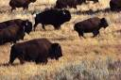

The Plains
Why was the buffalo important?

What happened to the buffalo during westward expansion of European Americans?

Horse Culture
When the Spanish introduced the horse to the Plains, the way of life of the Native Americans changed forever. How did the horse positively impact the daily lives of these people? How did the interaction with outsiders negatively impact the tribes and their way of life?

Warfare
What is counting coup?

American Flag Designs
Give three reasons why American flag designs were used in some Plains Indian’s objects.
1.
2.
3.

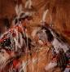

What’s in a (Tribal) name?
How did tribes get the names we know them as today?

Tipi
Look at the display of the tipi. Which direction does a door of a tipi face? Why?

List five facts about the Tipi.
1.
2.
3.
4.
5.

The Buffalo
List all the ways the Buffalo were used.

List some causes of the destruction of the large buffalo populations.

The Southeast
What allowed the Mississippian people to support large populations living in cities?

How did the Mississippian people import luxury items?

According to the text panel, the Mississippian people never developed a writing system. How did they communicate?

The Spiro Mounds
The text panel says: “Society was ranked with an elite class of leaders, warriors, and priests who were honored in both life and death with elaborate rituals.”

What other group(s) in history had a society system like the one mentioned in the quote above?

Film – “Spiro Mounds”
What does the narrator say about the diversity of the Spiro?

What does this say about prejudice in Spiro society?

What other group(s) in history had a diverse population?

Why did the Oklahoma government pass an antiquities preservation law in 1936?



Luxury Objects
Who does the text panel compare the Spiro to when discussing their luxury objects?

Touch Screen - Southeast
Use the touch screen to answer the questions that follow.
Tobacco – List five things the natives believed that tobacco was good for.
1.
2.
3.
4.
5.

Lacrosse - Who introduced the game of lacrosse to the southeast tribes?

Tribes – What two tribes lived in the Southeast?

Tribes/Caddo – What does the name Caddo mean in Caddo?

Tribes/Caddo - Where did the Caddo live?

Tribes/Caddo – How many people could live in a Caddo house? Make a sketch of the house below.

Tribes/Cherokee – What did the Cherokee homes look like? Make a sketch of the house below.

Tribes/Cherokee – How were decisions made in the Cherokee tribes?

Tribes/Cherokee – Why did the tribes have two chiefs? Do you think it was a good idea to have two chiefs? Why or why not?

Tribes/Cherokee – Why was the Cherokee alphabet important?

Region – Why was agriculture so strong among the tribes living in this region?

Ancient Traders
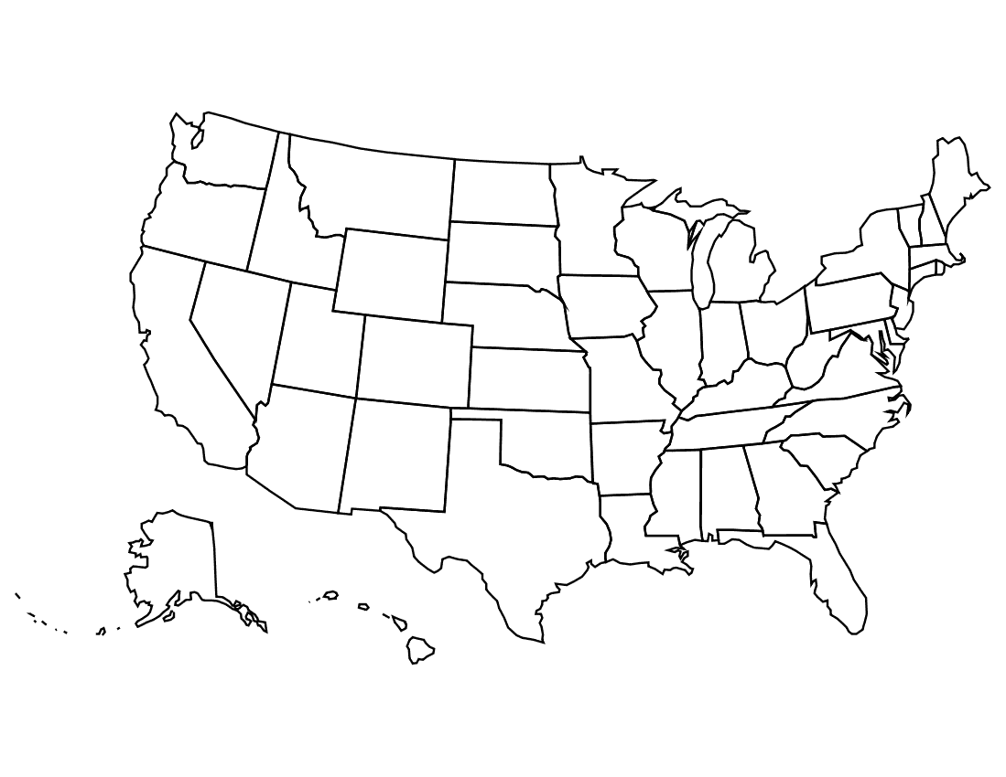
Use the map below to place the trade items in the correct area. Cooper, obsidian, pipestone, pottery, mica, and shells
After completing the map above, answer the question that follows.
Why do you think these items are most abundant in the areas they are traded in?

What made Spiro so Important?

How did the Spiro tribe earn so much of its power?

The Trail of Tears
Why was the forced relocation of the Cherokee called the “Trail of Tears”?

Tribes in Texas
Complete the chart below by filling in the locations.

Tribe | Original Location | New Location
Alabamas
Coushattas
Kickapoo

The Maya
Who ruled the Mayan Cities?

What old customs still remain with the Maya?

Jaguar Display
The text panel says: “Animals held a special place in the Americas before Columbus arrived. They served as friends, food, and the source of fables told to children. Each culture had different stories about dogs, turtles, iguanas, snakes, and frogs.”

Choose one of the items in the two display cases to sketch. You will use this animal when you return to class.

Touch screen titled “Jaguar: Protector of the Fields and Forest”
Chocolate - What did the Mayas call the chocolate trees?

Chocolate - Who or what is the patron of cacao?

The Aztecs and their neighbors
Describe the Templo Mayor (The Great Temple).

What happened to the temple?

Why do you think it was a good idea to include objects from all the people of Central America in the temple’s construction?

Find the “god” that was used to teach their children obedience. What is the name of the “god” figure? What did it do?

Find the model of the “ball game” to answer the next question.
When is it believed the first ball game occurred?

The Andes
Give four examples why the ancient Andes civilization is considered a story of human adaptation to a challenging environment?
1.
2.
3.
4.

Why do you think historians believe the “Inca might was built by superior organization.”

Sican Culture
What did the sun represent to the peoples of the North Coast?



Parrot Feather Poncho
Where did the peoples of the Nazca region get the feathers for this Poncho? How do you think they obtained these feathers?

Pre-Columbian Metallurgy
Why do you think the native people of the New World needed to mine gold, silver, tin, cooper, and platinum?

Read the three ways to process metals. Which do you think is the easiest process? Why?

Hall of Ancient Egypt

Third Floor

Vocabulary:
ancient, civilization, hieroglyphic, capitol, mummification, Christianity, flood plain, scripts, dilapidated, sarcophagus

Egypt: Gift of the Nile
On what continent is Egypt located?

What is the name of the river that runs south to north through Egypt?

Timeline of Egyptian History
What famous Queen ruled Egypt during the Ptolemaic Egypt (332 – 30 BC)?

Egypt’s Ancient Roots
What natural occurrence encouraged ancient Egyptians to leave the desert and move to the Nile flood plain?

The Predynastic Period (6000 – 3100 BC)
What artifacts suggest that Upper Egypt and Lower Egypt were culturally distinct?

Scripts and Writing in Egypt
What kinds of text were written in hieratic?

What were scribal schools?

Who was allowed to attend scribal schools?

Did you know? Naming Egypt
Why do you think the ancient Egyptians named their country Kemet to honor the Nile River?

Ramses II
Look at the large stone bust in the case. How do you think they transported this bust from where it was made to its final pace of honor?

Pharaoh: Lord of the Two Lands
What was maat?

To whom would the king offer the “spoils of war”? How do we know?

Temples
Who had access to the temples?

What would happen to older temples?

Mummification
List two types of protection that was important in the mummification process.
1.
2.

The Old Kingdom (Dynasties 3 – 6, 2682 – 2181 BC)
Where was the Great Pyramid built?

Who was the Great Pyramid built to honor?

The Late Period (Dynasties 26 – 31, 664 – 332 BC)
What technical disadvantage did the Egyptians suffer from during this time period? Who was better at it?

Third Intermediate Period (Dynasties 21 – 25, 1069 – 664 BC)
Why do you think historians believe the Nubian Pharaohs were more Egyptian than Egyptians?

List two innovations the Intermediate Period was known for.
1.
2.

Coffins became the main focus during the Intermediate period. What was painted on the coffins?

Sarcophagii
Are all sarcophagi coffins?

Roman and Byzantine Egypt (30 BC – 641 AD)
When did Egypt become a province of the Roman Empire?

What religious belief became popular during the 3rd century AD? How did this affect the burial process?

Strake Hall of Malacology

Second Floor

Vocabulary:
cephalopod, food chain, gastropoda

Class Cephalopoda
Choose one way a cephalopod defends itself and write down two pros and two cons of that defense.

Defense: __________________________________________.

Pros:
1.

2.

Cons:
1.

2.

Video: It’s a Squid Eat Fish World
Complete the food chain below.

Small Marine Animals ← Squid ← ___________________________

World’s Largest Snail Shell
What does the Australian Trumpet Snail eat?

How large can it grow?

Draw the development of the Trumpet Snail from egg to full grown adult.

Cullen Hall of Gems and Minerals

Second Floor

Vocabulary:
area, circumference, latitude, longitude, minerals, volume

Formulas:
Below is a list of formulas you will need to help you solve some of the problems in this Hall.
Be sure to show your work for every answer!
Circumference  Circle: C = 2πr  Area  Square: A = 4s  Rectangle: A = lw or A = bh  Triangle: A = ½ bh or A = bh/2 | Volume  Cube: V= s³  Cylinder V = πr ² h

Case 26 - #3 Cerussite
Look at the back mineral in the set. Imagine that it is a complete triangle. Determine the area of the triangle if b = 3 inches and h = 5 inches.

Case 31 – Quartz
Look at the rectangles on this mineral. Determine the area of one rectangle if l = 1.5 inches and w = 1 inch.

Case 42 – Pyrite
What is the area of the top square if s = 3 inches? What is volume of the entire cube?

Case 83 – Elbaite
What shape is the front of the mineral? What is the volume if r = 1 ½ inches and h = 5 inches?

Case 125 - #1 Rhodochrosite
What is the circumference of the side circle if the diameter is 3 inches?

Farish Hall of Texas Wildlife

Second Floor

Vocabulary:
destruction, genes, geology, inherit, learned behavior, niches, non-sustainable use, predator, prey, thrive, biosphere, organism, community, population, ecosystem

The High Plains
List three things about this ecosystem that helps its inhabitants survive.

Coastal Wetland and Marsh
Complete the chart below about the water birds you see in the exhibit.
Bird Name | What they use their beak for | Sketch of beak
Bald Eagle
Common Egret
Mottled Duck
Peregrine Falcon

Invasive Species
Watch the video about invasive species. Then, fill out the chart below.
Invasive species | Impact on environment | Positive/Negative?

Guadalupe Mountains
Choose one of the organisms from the scene in front of you and fill out the ecosystem pyramid below.

Organism

Population

Community

Ecosystem

Biosphere

Extinct and Vanishing Species
Which species are completely extinct?

What are the causes for each of the following species’ numbers diminishing? What is the current status?
Animal | Cause | Status
Red Wolf
Passenger Pigeon
Attwater’s Prairie Chicken
Carolina Parakeet
Ivory-billed Woodpecker

Piney Woods and Rio Grande Dry Forest
Use the chart below to find at least five biotic and five abiotic characteristics of the Piney Woods and Rio Grande Dry Forest regions.
Region | Characteristic | Biotic or Abiotic?

Migratory Patterns
Read the text panel in front of the Coastal Oak Motte region. What factors do these migratory birds have to worry about?
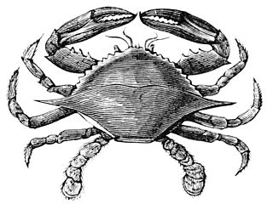

Hamman Hall of Texas Coastal Ecology

Second Floor

Vocabulary:
ecosystem, ecology, tidal zone, population density, salinity, hypersalinity, debris

As you enter the Hamman Hall of Texas Coastal Ecology, find Houston (Harris County) on the map of Texas. What is ecology and why might coastal ecology be important to us?

Upper Coast

Oyster Reefs
What is the economic importance of an oyster reef?

What other economic activities do you see represented in the oyster reef display?

What is the difference between salinity and hypersalinity?

Marine Debris
Use the tabletop touch display to find out more about marine debris. What is it?

Who is threatened by marine debris?

Middle Coast

Tides
What causes tides?

Brown Pelican
Observe the series of maps that tracks Brown pelican populations over time. Estimate the number of Brown pelican breeding pairs on the most recent map. How has the number increased or decreased from previous years?

Lower Coast

Texas Coast by the Numbers
What is the current human population in the 18 Texas coastal counties?
What is this population expected to be in the year 2050?
The human population is expected to increase by approximately what percentage in the next 35 years? Show your work.

Take a look at the sample of laws passed over time to protect our bays and estuaries. How have these laws changed over time? Why do you think this change has occurred?

Kemp’s Ridley Sea Turtle
As you round the corner of the Lower Coast section, you will see a large sea turtle laying her eggs in the sand.
Based on what you have seen so far in this exhibit, list at least three things the turtle requires for survival, and three things that could present a danger to it.
Needs for Survival | Dangers

Frensley Hall of African Wildlife

Second Floor

Vocabulary:
curator, destruction, genes, geology, inherit, learned behavior, niches, non-sustainable use, predator, prey, thrive

Africa Map
Label the regions of Africa on the map provided. While walking through the Hall choose one animal to represent each area and write down that animal next to the region’s label.

GeoFacts: What Makes Up the Continent of Africa?
What is happening to Africa, geologically speaking, every year?

What can you learn from the East African Rift System?

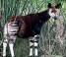

Congo Exploration
Why had the Okapi gone undetected until 1900?

Why has the Okapi population been restricted to around 10,000?

Congo Basin
How has the presence of humans changed the Congo Basin?



Rainforest – A Threatened Resource
The text panel says “Rainforests worldwide are threatened by destruction that comes from non-sustainable use.” What does “non-sustainable use” mean?

List two things you can do to help slow rainforest destruction?

1.

2.

West African Tropical Forest – Living Together in Harmony
On the text panel you are given two examples of animals using different types of niches to live side by side. After looking at the display of this region give another example of species using different niches to live in harmony. Hint: Think vertical plane.

Do you think the Lowland Gorilla would survive in the Serengeti? Why or why not?

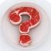

Threatening Survival in the Forest – The Bushmeat Trade
How does the bushmeat trade affect the animals in the Congo Basin and Ghana?

Okavango
Look at the Egyptian Goose and its baby. Why is it important that the adult Egyptian Goose pass down the genes that code for webbed feet, coloration, and beak shape to its young?

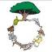

Lowveld
After looking at the display and reading the text panel, complete the food chain.

remains

Food Web Touch Screen
Look at the touch screen located in the Lowveld area of the Hall of African Wildlife. Try to guess which other animals will connect in each individual animal’s food web. After touch each animal explain if your predictions were correct.

The Morian Hall of Paleontology

First Floor

Vocabulary:
specimens, plate tectonics, offspring, ecosystem, habitats, extinction, Pangaea, carnivore, herbivore, organism, fossils

Snowball Earth
Draw and label “Snowball Earth”

Trilobite
Look at the second window of trilobites on the Cambrian wall. Notice that this shows a parent and offspring. Compare and contrast the offspring with the parent.
 | Parent | Offspring
Compare
Contrast

Middle-Late Ordovician| 472 – 443
Look at the 3rd window of trilobites on this wall. The two middle specimens were found in Canada. What other things do you see around the trilobites? Why do you think it would be found in this area? Hint: Think plate tectonics and where the oceans might have been.

Coelacanth
Examine the fins of the coelacanth. Do you think this fish would be a slow or fast swimmer? Would he thrive best in calm or fast moving water? Give two reasons for your answers.

Carboniferous – Seed Ferns
Look at the leaves of the seed ferns. How does it compare with a modern day fern? Has there been very much change over time?

Pangaea
Draw and label Pangaea below:

Guess which part of Pangaea contains the United States.

Late Permian – Feeding Time for Gorgons
How many different habitats can you see in the mural? List them below:

Estimate how many different ecosystems would be affected if the water dried up.

Extinction Event
Take a moment to examine the Earth at the end of the Permian. You may alter your guess about where in Pangaea the U.S was located if you need to. How have things shifted since the early Permian?

Archosaur vs. Desmatosuchus
Study the teeth of these two animals without reading the text panel. Identify which one is an herbivore and which is a carnivore. How do you know?

Herbivore: ________________________________________
Why?:

Carnivore: ________________________________________
Why?:

The Early Jurassic Ocean
What do you think would happen to this ecosystem if oxygen was removed? Hint: The horseshoe crab next to the mural is a good example of what happens to an organism that is deprived of oxygen.

Jurassic Motherhood
Examine the Ichthyosaur on display paying special attention to her stomach. Can you find all eight of her pups? Note the large head size. Why do you think these babies would need a large head at the start of their lives? Hint: Think food.

Gorgosaurus
Look closely at the legs of Gorgosaurus. Do you notice a bone sticking out? What do you think happened?

“Stan” the Tyrannosaur vs. “Lane” the Triceratops
Based on their physical appearance, which one is hunting the other? Explain your answer.

Quetzalcoatlus
Does this animal give live birth like “Jurassic Mom”?

Which baby (Jurassic Mom or Quetzalcoatlus) do you think would be most dependent on mom after birth? Justify your response.

Hippo-Rhino – Chilotherium
Look at the map. What type of Rhino ventured into North America? Are they still here today?

Pliocene and Pleistocene
Look at the different scenes set-up with fossils during this time period, from the Mastodon swimming in the ocean to the cavemen hunting the mammoths. List two reasons why all these large furry animals became extinct.

1.

2.

Foucault Pendulum

First Floor

After reading about the pendulum from the touch screen answer the questions that follow.

What makes the pendulum swing, rotate, and spin?

Would the pendulum spin in a rotation if it were located anywhere near the equator? Why or why not?

Wiess Energy Hall

First Floor

Vocabulary:
alternative energy, basin, continental plate, fault, hydrocarbon traps, non-renewable energy, petroleum, plate tectonics, renewable energy, sediment, sedimentation, seismic, topographical map

Video: Formation
What is the origin of energy on Earth?

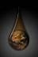

Video: Energy Is…
While watching the video, list three non-renewable energy sources. Where are these sources found?

List the four sources of renewable energy that are discussed in the film. Which do you think is the most practical? Why?
1.
2.
3.
4.

Most Practical: ___________________________________.
Why:

Touch Screen: Plate Tectonics
Remember, oil has formed under the ocean. Use the touch screen and watch the plates shift around the Earth. Follow Texas over time as the plates shift and move and respond to the following questions.

Why is oil so abundant in Texas?

Where else on Earth might you find a lot of oil?

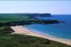

Sedimentation
Look at the working display of sedimentation. Explain how the shoreline changes as waves circulate around the loose sediment.

Touch Screen: Basin Formation and Filling (click on “Play Movie”)
Draw the three phases of a basin formation and filling.

Touch Screen: Basin Formation and Filling (click on “More Information”)
Why is the Great Rift Valley, in Africa, a good example of an active rift splitting a continental plate and forming a basin?

Touch Screen: Topography: Faults
How is a fault located?

How does recognizing the existence of a fault impact the search for oil?

Seismic Section
What is a seismic section?

Name two elements that scientists look for in a seismic section that would lead to potential hydrocarbon traps.
1.
2.

What causes “bright spots”?

Keep in mind that drilling through salt destroys your drill bit. Find a location on the seismic section that would be the best place to drill for oil. Draw the section you choose to defend your answer.

Touch Screen: Reservoir and Production
What is the most common type of artificial lift?

Explain how a common artificial lift works.



Energy Excursions Theater
Watch the movie and list the main sources of energy.

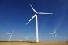
List the types of alternative energies covered.

Choose two sources of alternative energy and describe which of the two has the greater economic/environmental impact. Use at least three reasons in your argument.

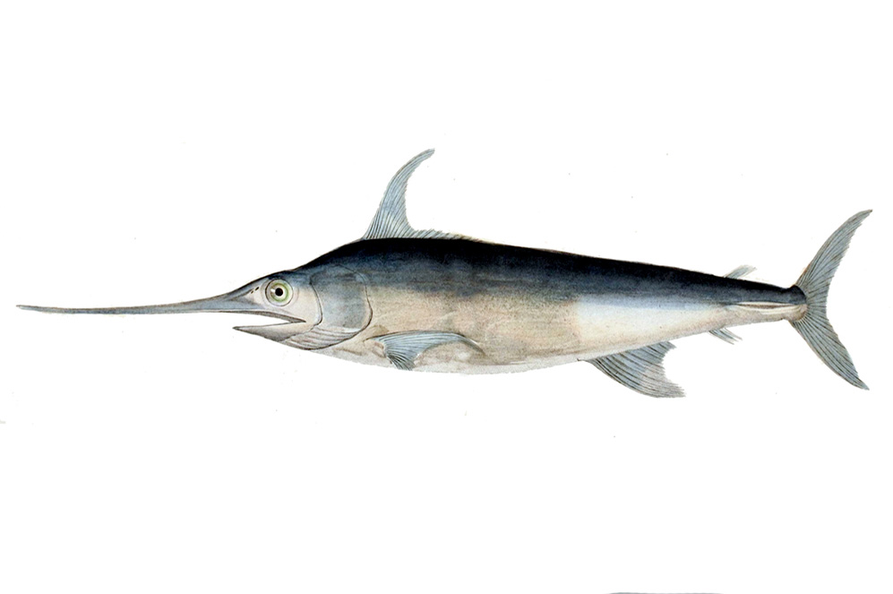
Alfred C. Glassell Jr. Hall

First Floor, Main Entrance

Vocabulary:
inherit, learned behavior, niches, non-sustainable use, predator, prey, thrive, biotic, abiotic, predator, prey, consumer, producer, organism, environment, community, population, biosphere
Identify as many biotic and abiotic factors as you can within the ecosystem presented in this hall.
Biotic | Abiotic

Choose one of the organisms on the wall or hanging from the ceiling and fill out the ecosystem pyramid below.

Organism

Population

Community

Ecosystem

Biosphere



The Welch Chemistry Hall

Lower Level

Vocabulary:
alloy, atoms, diameter, haze, matter, neuron, oxygen, nitrogen, energy transformation, percentage, metalloid, nonmetal, metal, hydrogen, iron

Element Identification
Students will use the touchscreen Periodic Table of Elements to match the correct symbol to its element name in the space below.
Symbol | Element Name
Al | Gold
C | Aluminum
Au | Oxygen
H | Carbon
Fe | Hydrogen
O | Iron

Metal, Nonmetal, Metalloid
Instruct students to observe the periodic table on the wall. Using the touch screen, students are to choose three different elements: one metal, one nonmetal, and one metalloid and complete the chart below:
 | Element Name and Symbol | Characteristics
Metal
Nonmetal
Metalloid

Air Molecules
The lights in the ceiling represent the elements in Earth’s air. Using the wall panel a guide, students will determine how many of the lights on the ceiling represent each element. Assume that the total number of lights is 100.
Element Name | Percentage | Number of Lights
Nitrogen
Oxygen
Argon

Energy Transformation
As students explore the Welch Chemistry Hall, explain to them that there are several examples of energy transformation taking place. Have them identify at least three different instances and describe what is happening. They can use the chart below to record their observations.
Example | Energy Transformation
Flashlight | Chemical → Electrical → Light



Weather Center

Lower Level
In groups of four or five, students should rotate the roles of “weather person,” “camera person,” and audience. While reporting the weather and operating the camera, students will experiment with lighting, sound, camera angle, posture, voice level, and delivery skills. The audience will listen and view the presentation, critiquing both performances. The audience will rank the skills of each person on a scale of 1 – 5 with 5 being “very skilled”.

“Weather Person”
 | 1 | 2 | 3 | 4 | 5
Posture
Voice Level
Delivery Skills

“Camera Operator”
 | 1 | 2 | 3 | 4 | 5
Ability to “frame” the subject

Solar System

Outside Main Entrance

Vocabulary:
asteroids, comets, meteorites

Chose two planets to sketch and copy down the information given in the text panel. When you return to class you will use this information.

